Investigating liquids
Experiment 1 – Coin test (density)
Aim: To see how well a liquid holds together with a few drops are placed on a coin
Materials:
- 3 different liquid samples of substances (Eg. Detergent, oil, water, tomato sauce, soy sauce, milk or sweet chill sauce)
- Eye dropper or spoon
- Coin
Method:
- Gather the materials listed above.
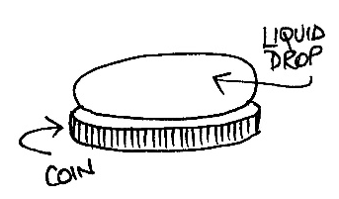
- Take each liquid individually and carefully see how many drops of the liquid can be placed on the coin without it spilling over. Record this in the results table below.
- Repeat for each different sample of liquid.
Results:
- Record your results in the table below.
Name of liquid | Number of drops

Discussion:
- Which liquid held together the best? Why?
- Which liquid could support the least amount of drops?
- This experiment relates to the density of different liquids. Look up the term ‘density’ and explain what it means.
- Which liquid was the most dense?
- Which liquid was the least dense?

Experiment 2 –Viscosity
Aim: To investigate the viscosity (runniness) of different types of liquids.
Materials:
- A smooth surface you can place on an angle. Eg. A book, a chopping board etc..
- Ruler
- Stopwatch (on phone is good)
- A set of different types of liquids ( can use the same ones as from experiment 1)

Method:
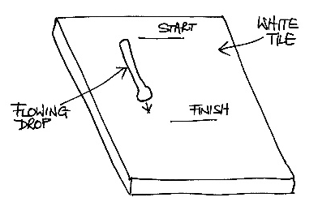
- Hold the smooth surface at a slight angle.
- Take one of the liquids at the top of the tile and time how long it takes to flow 5 cm down the tile using a stopwatch. Record your results in the table below.
- Repeat this for each liquid, ensuring you start at the same point for each of the liquids.
Results:
Fill in the table below with your results:
Name of liquid | Distance travelled (cm) | Time taken (s)

Discussion:
- Look up the term viscosity and define what it means.
- Which of these liquids was the most viscous? Why?
- Which of these liquids was the least viscous? Why?

